Zu den Reiseberichten
Array
deutsch

2023: Tirana, Albanien
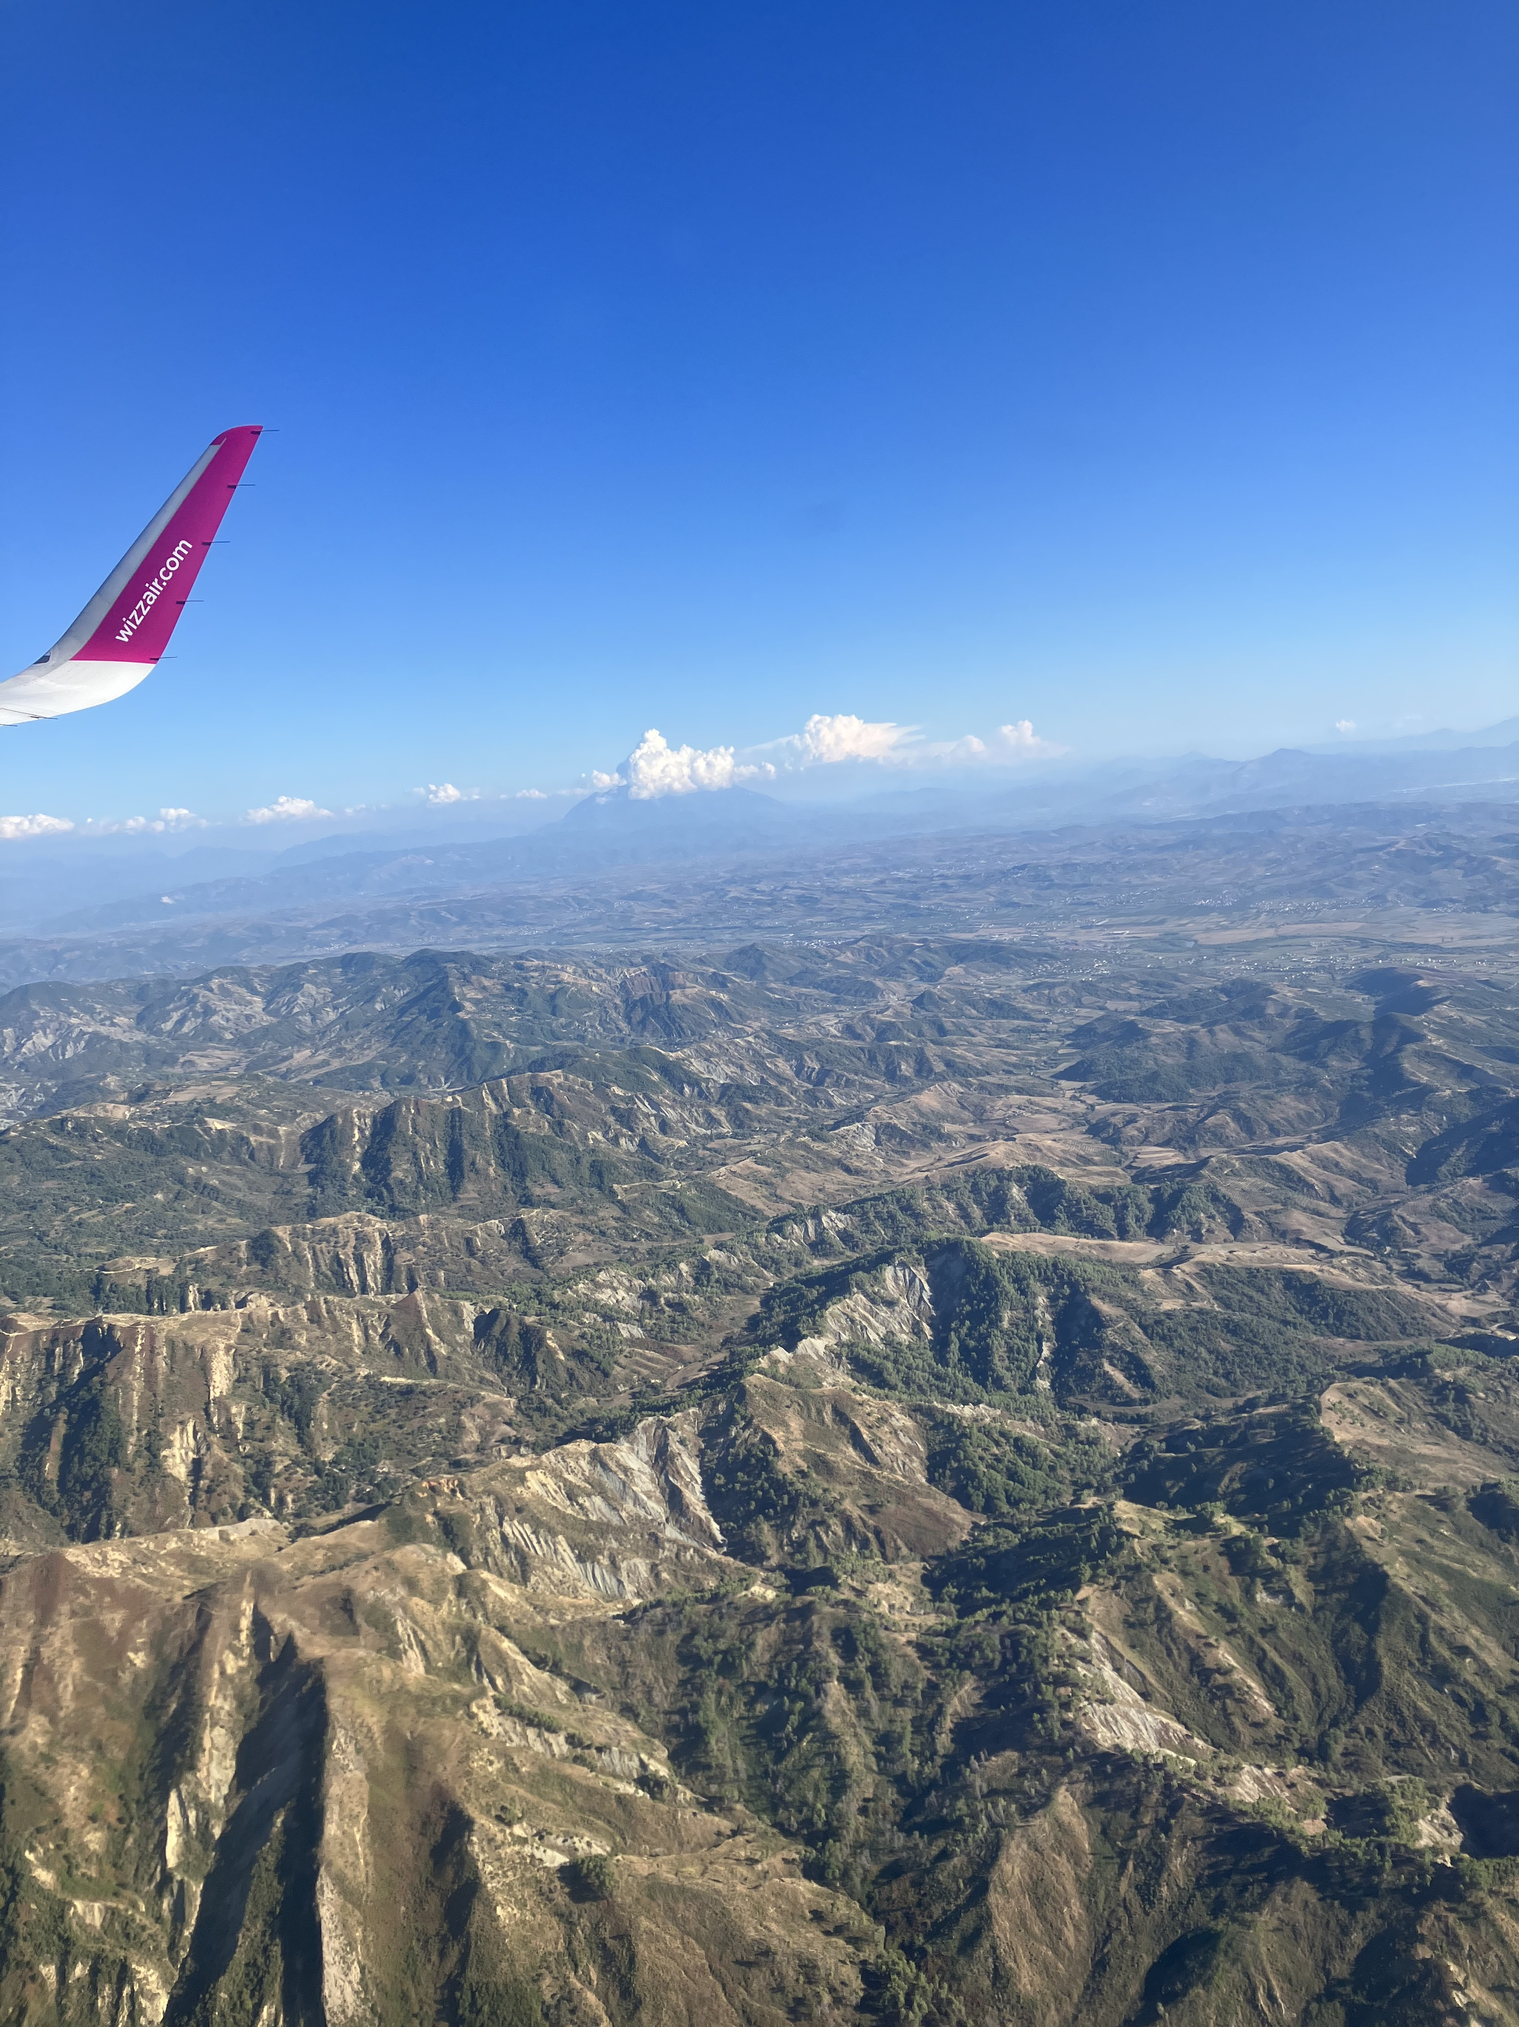
( 17.- 23. September 2023)

17 September, on the plane
On the way to Tirana, I try to eavesdrop on my questions for this trip within myself. Albania is a small country that is not part of the EU, but has been a candidate country since 2014. Accession negotiations started on 19 July 2022.
In 1991, a communist dictatorship that had lasted 45 years and was one of the most extreme in Europe, the regime of Enver Hoxha, collapsed in Albania. In 1991, a traumatised, impoverished and isolated-backward country was released into a democratic future. The Hoxha period was, I think, a complete antithesis to what for me constitutes the ideal of „the West“. I wonder if I could make that ideal my motive here. To what I am looking for, as a reality or as a longing - or perhaps what I cannot find and what is evident in its absence. What is the promise of the „West“? Can it gain a foothold in a society that in 1991 consisted almost exclusively of perpetrators and victims of a brutal authoritarian system? How did or does the transformation from there to a subsidiary society take place? Is there even a prospect of this? How does one see the real, inert, complacent West from Albania? Is there also that bitter disillusionment here that I keep encountering in the East of the West? Are we perhaps beginning to see the alternative to the West in the authoritarianism of China, Russia or Turkey as the lesser evil to Western hypocrisy?
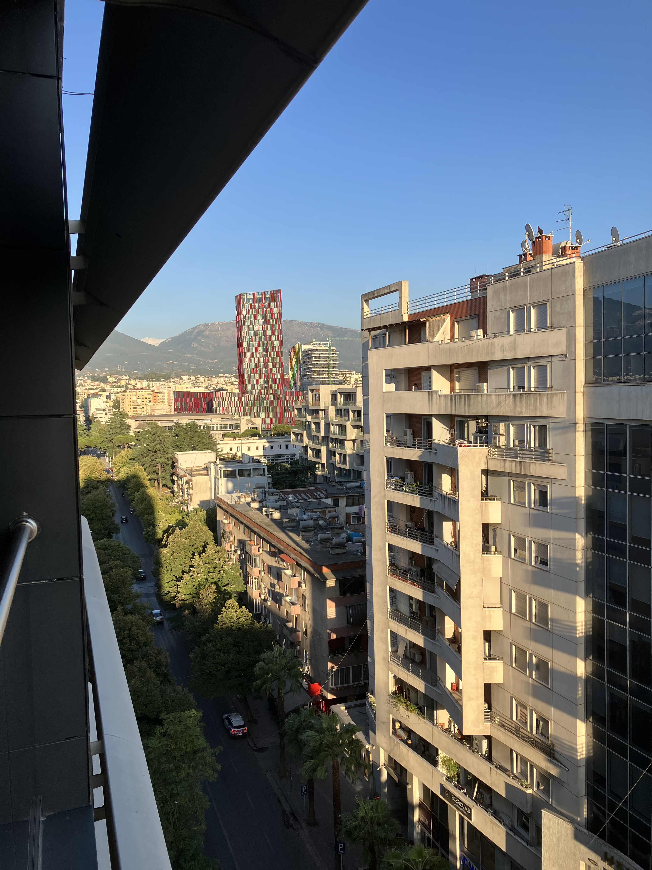

Zu den Reiseberichten

