Zu den Reiseberichten
Array
deutsch

2023: Visiting the EU in Brussels
(24-29 April 2023)

(in translation)

1: On the way to the centre. Right?
The journey continues along the beautiful bends of the Rhine on a sunny morning. As if all is well with our world and our Europe. As we pass through Bonn, it starts to rain.
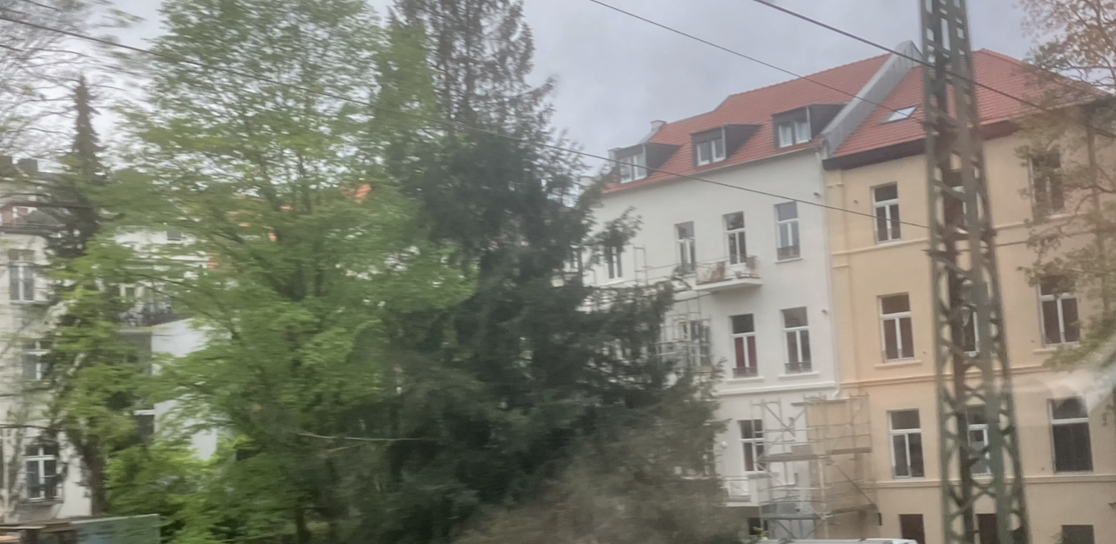In Bonn beginnt es zu regnen
In my reflection on Europe, I do not want to forget the administrative centre, the political heart in Brussels. Or the Moloch, as some say, the fortress of heartless bureaucracy. Has a European identity emerged since it existed, the European Union? Something that endures and is resilient? A goal and theme for something like patriotism and also sacrificial willingness? Or is it just an economic community of convenience whose cultural encroachments the patriots of the nation states deplore and fight against? Does „Europe“ exist in Brussels?

The Commission
The European Commission is the administration of the European Union. It has many of the tasks of a government, but is not elected; instead, the commissioners (ministers) are appointed by the nation states on the basis of complicated proportional representation. In addition, there are the 30,000 civil servants. They are officials of the Commission and form the engine room of the EU administration. The crew that drives the ship - under the command of changing officers, but necessarily largely independent in their day-to-day work. They are employees of the Commission, not of the nation states. The officials from the United Kingdom will also remain here despite Brexit.
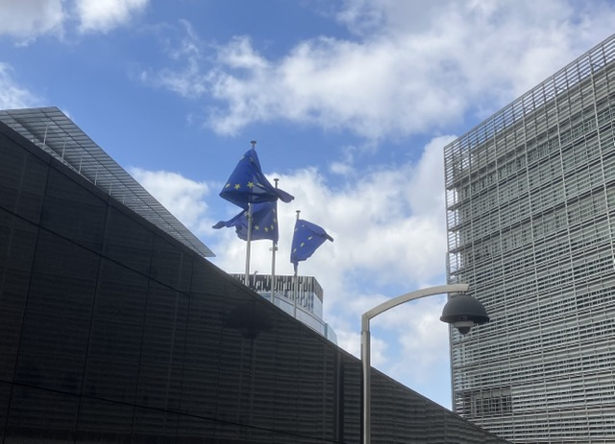
The architecture of the Commission buildings is monumental and new. It is not an old building stock of a seat of government that has taken a metamorphosis into a democratic system - but the mirror-glassed administrative centre of a new empire. That's how it looks to me. Apart from the imposing overall effect, everything here strives to convey closeness. There is friendly art, friendly security staff and somehow the security gates are friendly too. As if they were only half-serious.\
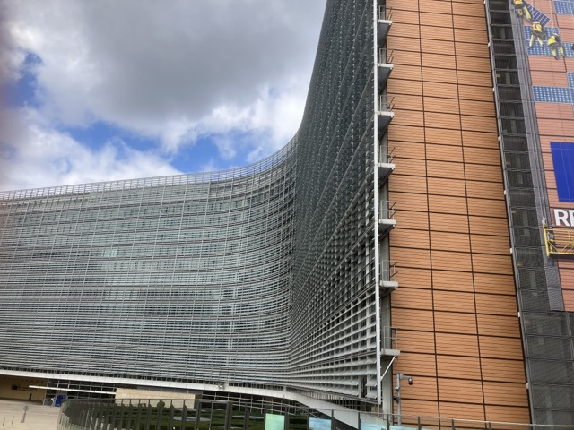
We meet two officials from the „Mobility“ and „Climate“ directorates on the study tour. They tell us about the tasks of the Commission, about which aspects and how Europe is governed from this headquarters. I only get an idea of how complicated the structures are that manoeuvre between national and supranational responsibilities. Both officials have been here for decades, and I think I can hear in the overtones: the two are not overwhelmed, weary or aimless. They see themselves as part of an institution that has now been around for a long time and that works in principle. They speak of models, probabilities and of very long-term developments that escape the public eye and day-to-day politics. I ask both of them about the dwindling enthusiasm for the European Union among the populations of the nation states. They don't seem to understand me and talk about regulations being implemented and that there would be no major problems with that. Perhaps I did not formulate my question well? Or maybe it is just that their gaze is fixed on a point on the distant horizon, overlooking the near surroundings? There is something in that that I find reassuring, I am surprised to realise.
In the evening, we meet a few staff members of MEPs, they tell us about their work and their convictions. I feel the wind of change in our times, but it feels different here, so close to the decisions. Our conversations are strangely concrete, determined and at the same time cautious, as if words could have consequences here.

A lobbyist
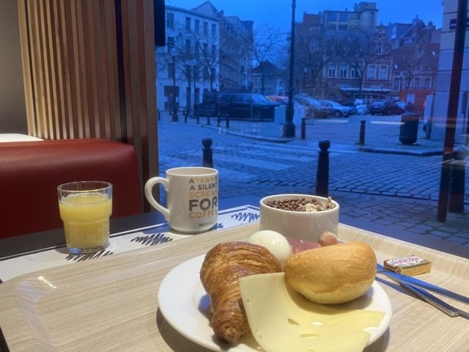
At breakfast I want to write my travel log, but a conversation arises with a German company representative who is preparing an appointment with a member of parliament. It is about the new EU legislation, the „Green Deal“. Her company needs more land, but fears that the EU rules will prohibit it. This would ruin the company or force it to emigrate. She wants to argue that in 20 years (after the desired management of the land), the company would renaturalise the area to a higher quality. Then a CO2 sink would be created, which would turn the entire climate balance of the project into a positive one by the year 2100. The MEP should be convinced to bring this position into the political process and to try to move the Commission to find a derogation.\
Just another morning in a hotel in Brussels, I suppose. I ask the woman if she is a lobbyist. She hesitates, can't see herself that way personally. Although she does represent interests… is that already lobbying?
We part again, wishing each other good luck. It could be that we will meet again soon, because we have the same plan: we are going to the EU Parliament to meet an MEP. I think about it. I too have an interest in this, I want to inform myself, to educate myself and I have my art project in mind. Is that lobbying already?
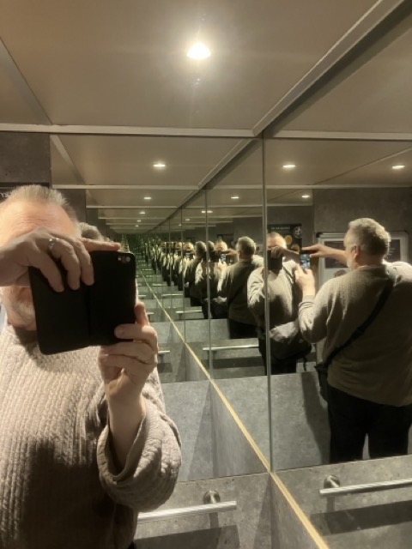

At the Parliament
The architecture of the ensemble around the European Parliament in Brussels embodies the same aspiration as the houses of the Commission: the staging of imposing centres of activity of a new and rising power. From the parliament building, a stairway leads to a higher square. The step length of the staircase does not fit the human measure, it is unpleasant to walk it. I don't believe it was an accident on the part of the architect. One is supposed to feel small on these stairs, physically somewhat inadequate compared to the surrounding grandeur and consecration. A new empire is claiming its place on the world stage and wants to make its mark.
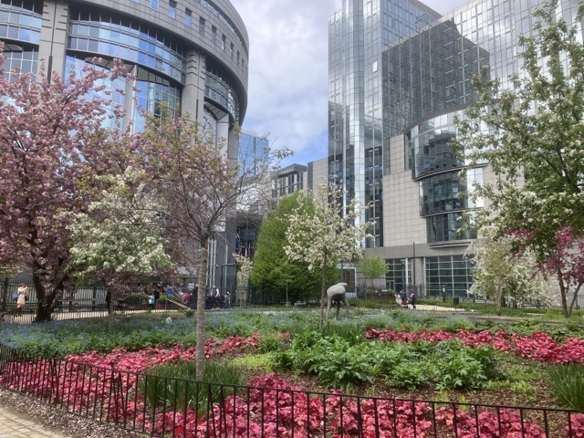
But on the whole it is quite nice here, the gestures of grandeur and power are broken and softened by gestures of welcome. Chairs, benches, transparent lines of sight to reception rooms. There are green areas and, next to the long queue of people at the visitors' entrance, something that I first think is a huge insect hotel. In its outsized harmlessness it says to me: this empire must come across as appropriately awful and grand, but nevertheless it wants to be „your empire“! You, with your personal views and needs, are not an onlooker here, but the master of the house.
Pawel in Krakow calls this attitude the subsidiary heart of the West. Subsidiarity here means: the individual has significance, rights and dignity vis-à-vis the state and the community. This is a very short definition for the essence of the „West“ and its distinction from the emerging authoritarian systems in the world. One can also say „liberal conception of man“.
I see the message of this freedom in the architectural ensemble in the European Quarter. But at the same time, a powerful self-confidence should be radiated.
I feel a little sorry for the buildings because of the wide balancing act they have to perform in their outward appearance. But I now gladly forgive them for their exaggerated grandiosity. And by the way: the „insect hotel“ is actually part of an ambitious ecological Urban Greening Plan.
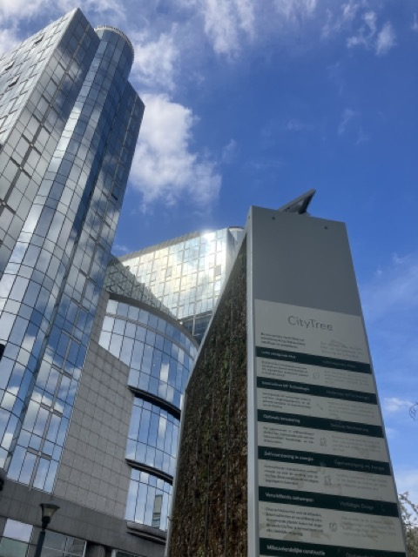
Unlike the European Commission (European „government“) and the European Council (governments of the nation states), the Parliament aims to be as accessible and transparent to citizens as possible. Many sessions are streamed live and many votes are by name and open to the public. The Parliament, with its surrounding facilities, is the place where the wishes of the people of Europe are to be incorporated into the negotiations of power and governance. Not only those of individuals, but also the wishes of businesses and interests of all kinds. Here they are all invited to express themselves and to have an influence. Like the woman at the breakfast table this morning for her company. Or me for myself and my art project.
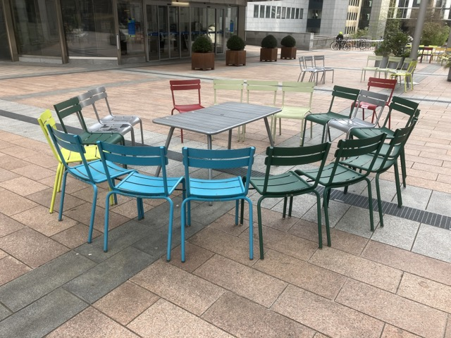

Opposing opinions
In Brussels, there are many opinions that interact with each other. Even those that would be mutually exclusive if they were reduced to simple propaganda stories. An MEP explains to our tour group his position on the war in Ukraine and a possible European security structure in the future. I don't share his opinion on many points, but I am happy to see him present his view to us.
I think about how difficult the struggle for compromise must be in the committees and in the plenary of the Parliament. More than he presents it, I think the MEP's opinion is a minority opinion in the European Parliament and I am glad that it is so. But it must be hard for him to accept the position of the majority, which he considers an existential mistake. He fights against it with well presented arguments. Even though I hope that he will not be able to prevail on some crucial points, I think it is possible that a now unforeseeable future will confirm his opinion - and not mine. Today, however, we have to make a decision without this knowledge if we don't want to bury our heads in the sand. Which is also a decision.
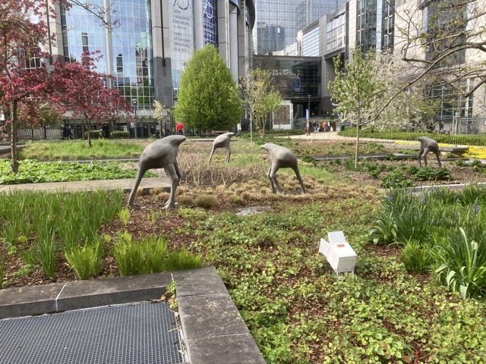
In any case, I would like to believe that in the Parliament of Europe, different opinions will continue to endure and exchange each other. Even in the worst times of existential threat.
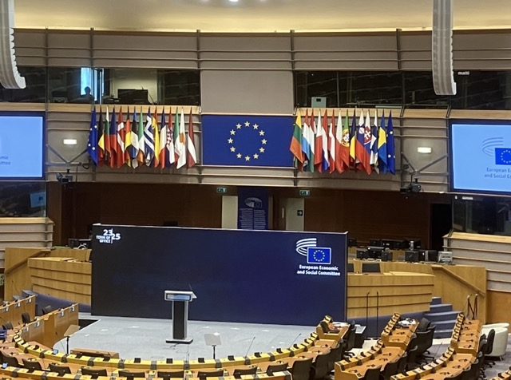

Council of the EU, European Council and Council of Europe
These are three completely different bodies, only the first two belong to the EU.
The European Union is a federation of independent states (currently 27) without a common government. Although the EU Commission takes on many governmental tasks, the governments of the sovereign nation states always have to agree to transpose the EU's requirements into national law.
This is what the Council of the EU is about when it meets and votes on the Commission's proposals. The Council consists of the ministers of the nation states in different compositions for the various departments. In the EU's legislative process, this Council of Ministers is one of the three decision-making bodies. It is also called the „Chamber of States“, to which the EU Parliament is added as the „Chamber of Citizens“, and the third is the EU Commission.
In the European Council, the heads of government of the nation states rarely come together for a summit meeting. The European Council only has to deal with the EU's legislative procedures when the Council of Ministers has failed to reach agreement. Otherwise, the European Council only deals with fundamental issues. For example, the general political direction of the EU, the election of the Commission President, the Foreign Affairs Commissioner and reforms in the EU's framework treaties.
However, once elected, the Commission President is obliged to serve the interests of the EU (like the Parliament) and not the interests of the nation states. Considering how powerful the position of the President of the EU is, there is something provisional in this construction. Something that can actually only work with difficulty: mandated by the intergovernmental European Council, the President is at the same time supposed to be the greatest initiating force for the supranational interests of the EU. And thus a servant of two masters, because the general EU interests are in many cases very different from the interests of the national governments.
The Council of Europe, with its seat in Strasbourg, was founded in 1949 and has nothing directly to do with the European Union, even though they fly the same flag and have the same anthem. 46 states are members, including Azerbaijan, Armenia, Georgia, Ukraine, Turkey and Great Britain. Russia was excluded on 16 March 2022. All EU member states and candidate countries are members of the Council of Europe, which promotes human rights and aims to foster closer union among all its members.

Decision-making in the EU: The theory
In the institutionalised process of EU decision-making, the President of the Commission has the first move. This person formulates an intention for a new direction, directive, regulation. In doing so, he/she is free to follow the recommendations of the European Council (the european council conclusions) or only his/her own initiative as the highest representative of the EU.
First, she works out a proposal with her Commission, which she passes on to the Parliament as a proposal. There, a committee takes up the matter and draws up a report (i.e. a list of proposed amendments) and submits this report to the plenary (full parliament) for a vote. Then the Council of Ministers takes the Commission's proposal and Parliament's proposed amendments and formulates its own proposed amendments. If the Council agrees to a revised decision by the Parliament and the Commission does not withdraw its proposal (which it can do at any time until then), there is now a new EU measure. From now on, the member states of the Union have two years to transpose it into their national legislation and administration. After that, if the new measure is a „regulation“, the nation states face infringement proceedings and punitive measures.
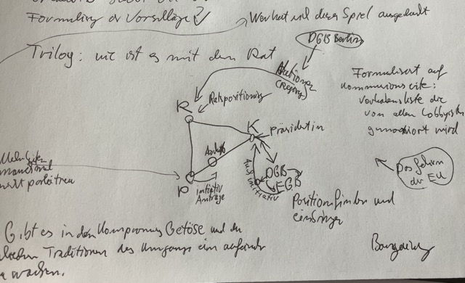

The Trilogue
That's how it would work if the Commission, Parliament and Council were in direct agreement. That happens sometimes. If not, i.e. most of the time, the three legislative bodies of the EU enter into the trilogue. The trilogue is actually not a formal procedure, but the name for a cooperation that exists in the environment of the EU's decision-making processes. Something that has been established over the years and decades and gradually became so clear that it was given a name. The trilogue is not part of the rules of the game, it is the way the game is played.
There are attempts to formalise the trialogue and put it into rules. I can understand this administrative wish, because the trialogue is a rather untamed way of decision-making. And the trilogue game is not limited to the organs of the legislature, but the boundaries of influence are open. First of all for the advisory committees from the regions and civil society of the EU, for the representations of the countries, for expert bodies - and ultimately for many interests that try to make themselves heard. This is a threat to the transparency of EU processes and to the principle of participation, the opportunities for everyone to have a say in everything.\
But: the more legislative rights the EU Parliament has gained over the years, and the more equal the Parliament has become in relation to the Council and the Commission, the more important it has become to talk to each other. You have to negotiate to find creative solutions. Creative processes (I know about that) include saying and doing things that you don't yet know where they will lead. This cannot be done in full view of the public. You need trust and the courage to make mistakes. In absolute transparency, this cannot happen.
A surging back and forth of quiet and loud exchanges of opinions, that seems to me to be the very lively reality in the European Quarter of Brussels. With developed and proven rules, but also with the freedom for creative exchange. A freedom that has broken through within a rigid and constructed set of rules. As life always does when the soil has become fertile enough.
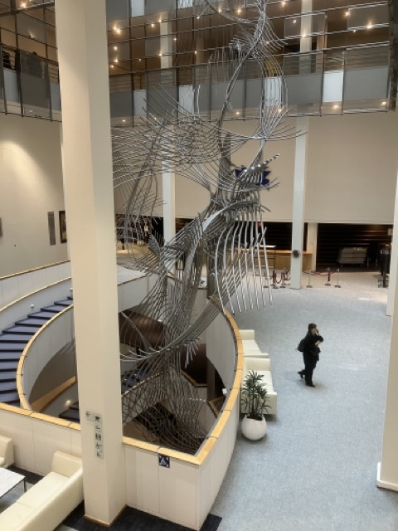

Freedom and arbitrariness
Freedom and arbitrariness look similar, but they are opposites as far as their inner justification is concerned. In a space of possibilities, freedom is a force that wants to fill this space from within and expand it in a living way. While arbitrariness attacks the same space from the outside and with foreign intentions, corrupting its possibilities and causing them to die.
In the heavy rain of lobbyism over the EU in Brussels, its freedom has to assert itself against arbitrariness under the harshest conditions. In such a situation, freedom can only endure if it is held and protected by firm principles. By an unwavering attitude that does not consist of additional rules but has the character of a faith.
The European Union has outgrown its infancy. It is no longer found cute and loved for it. It is no longer promoted like a youth in which hopes are placed. In order to exist today and in the future, the EU must prove itself independently. Does it have the strength to develop further by acting in the harsh reality? For this, it needs an inner stability, something that defines it; an identity. I have been looking for this identity and would now like to answer the question I asked at the beginning of this journey: „Does Europe exist in Brussels?

What is "Europe" in Brussels?
The EU is sometimes perceived and portrayed as a heartless bureaucratic monster. The aim of my trip was to see if I could make sense of what the EU does. Behind the rules and regulations, the excessive evaluations, the sometimes incapacitating interference. A meaning that I not only wish for, but that I encounter as something that exists.
I consider the following three principles to be deep convictions at the EU in Brussels. Not as rules, but they belong to an attitude to which rules have to justify themselves - and out of which new rules can emerge:

1. Proportional representation
No one in Europe should have an advantage over anyone else: No nation; no language; no group of states; no gender; no minority; no majority; no level of education; no disability; no creed; etc. And no one should be able to decide on anything alone without the others.

2. The compromise
Everyone has to agree all the time. Within the Commission. Within the parliamentary committees, within the Council. Within the consultative bodies. Because of proportional representation, this is very difficult and probably often very frustrating. As one Council of Regions official puts it, „A good compromise is when everyone is unhappy.“ Winning, as I understand him, is about winning together. Not one against the other.

3. Subsidiarity
This is the heart of the „West“: everyone is allowed to decide for themselves. Unless a decision affects someone else's freedom of choice. Then the attempt and the necessity to agree begins. No, not only then, but already in the run-up, proportional representation ensures a balance, a fair basis for the compromise negotiations.
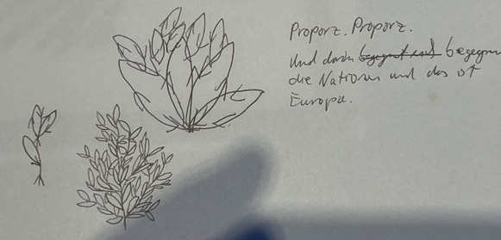

Conclusion
The EU is a terribly complicated marketplace of agreement processes and influencing. And in it, the whole European diversity constantly encounters itself, in such a diverse way that probably no one has an overview any more. But there is no need for that, and perhaps it is better that way: in the end, Europe and the European Union will have to trust in their own identity. This confidence would be the „unity in diversity“ that the European Union desires and which I believe it can achieve.
Despite all the shortcomings in the methods and in the implementation.
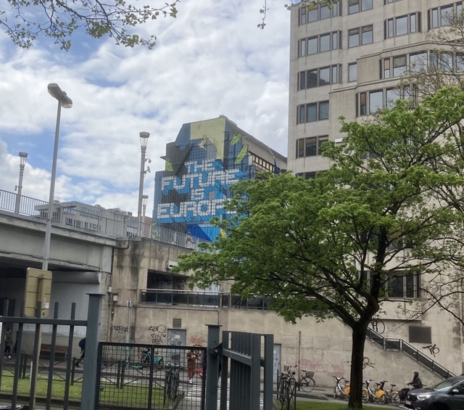
Stefan Budian,
Mainz, 30 April 2023

Postscriptum: in the Rhineland-Palatinate State Representation
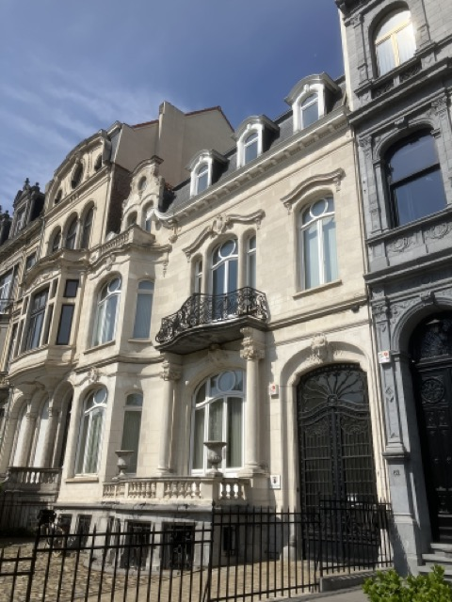
In the Permanent Representation of Rhineland-Palatinate, I think it would be nice to show my project „The East of the West“ in Brussels. It's a project that was created in Rhineland-Palatinate and deals with Europe and I would like to invite „the EU“ to notice it.
As a lobbyist for confidence in the strength and dignity of the process of European unity.
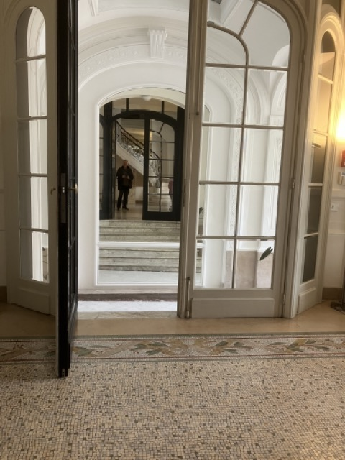

Zu den Reiseberichten

