To the overview “Resonanzräume der Usien“
<< previous | next >>
Array
deutsch
 polski
azerbaycan

Room 12a – Without dark nights (Aysel)
In the Silence After the Anthem
South of Şəki, on a low hill, stands a house that smells of almonds. The shutters are crooked, but not broken. Aysel, 64, lives here alone. She was once a music teacher. Now she tunes her voice only rarely. Sometimes, when no one is listening, she hums the old anthem from 1919—not out of patriotism, but because she can’t forget its rhythm. “It was like a dress we were allowed to wear only briefly,” she says of the republic that lasted less than three years. “Then, suddenly, winter came again.” Her husband died in 1990 while fetching food in the capital. Their daughter now works in Istanbul. She writes seldom, but regularly. Her short, formulaic messages contain no questions—only states of being. On the wall hangs a framed verse by Hüseyn Cavid:
“Gäbe es nicht die dunklen Nächte, würden die Worte liebkosenden Sterne weniger geliebt.”
(“Without dark nights, the words that caress like stars would be less beloved.”)
Aysel believes Cavid didn’t mean stars themselves, but what remains between the words: the silent dignity. Sometimes she walks to the edge of the village, where the view fades into the mountains. There, she believes she recognizes the day when everything ceased to feel like a future. And there she begins to sense the day when something new was born—without a song, without a flag, without a slogan—only the need to no longer feel foreign in her own land. She says: “I have stopped waiting for a sign. Now I listen to the spaces in between. They say: You were here. And you are still here.”
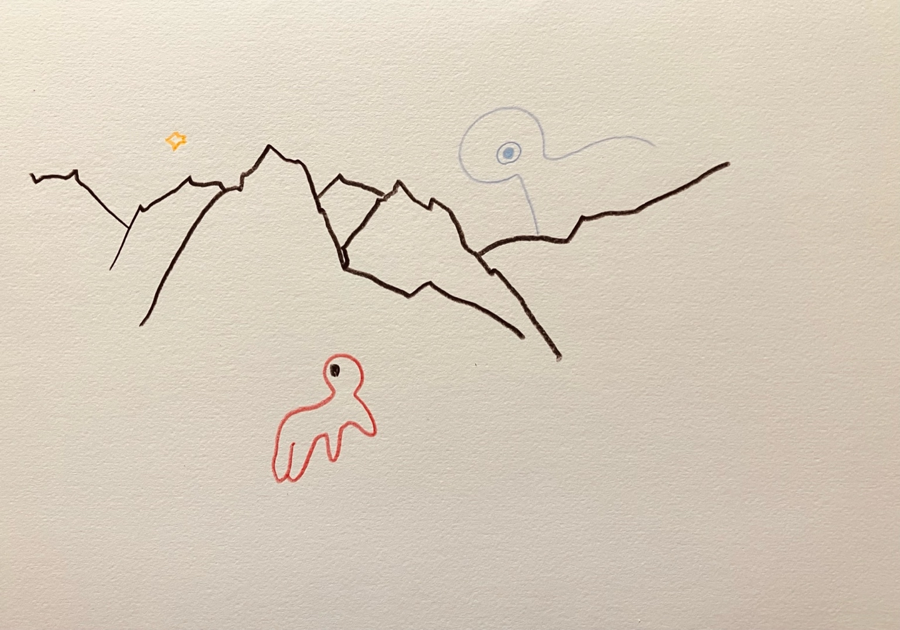resonanz_25-012

To the overview Resonanzräume der Usien

