To the overview “Resonanzräume der Usien“
<< previous | next >>
Array
deutsch
polski
slowakia

Room 10 – Keravlónomos
The story doesn’t begin with lightning, but with breath. In a small Greek village near Kalamata lives Giorgos, 74 years old, alone in a house with white walls and quiet rooms. He was an electrician for most of his life. People used to say: “He doesn’t talk much – but when he does, it’s true.” Now he hardly speaks at all. His voice clings to the edge of his mouth like a child unsure whether it’s allowed to interrupt. This morning, mist lies over the valley. Giorgos steps out barefoot; the grass is cool underfoot. On the hill stands a single, rusty lightning rod – inactive for decades. Giorgos installed it himself, back in 1982, when his son was born. He stands still. Then lifts his hand and touches the old metal. He says: “I am ready.” The sky twitches. No rain, just light. Not even loud. Just a current that flows through him – not destructive, but remembering. Later, Giorgos sits in the kitchen and writes for the first time in years. Just one word: Keravlónomos. He says it means: “The one who allows the lightning to touch him without burning.” In the evening, his breath will be quieter. Not from fatigue. But because something heavy has left him that will not return.
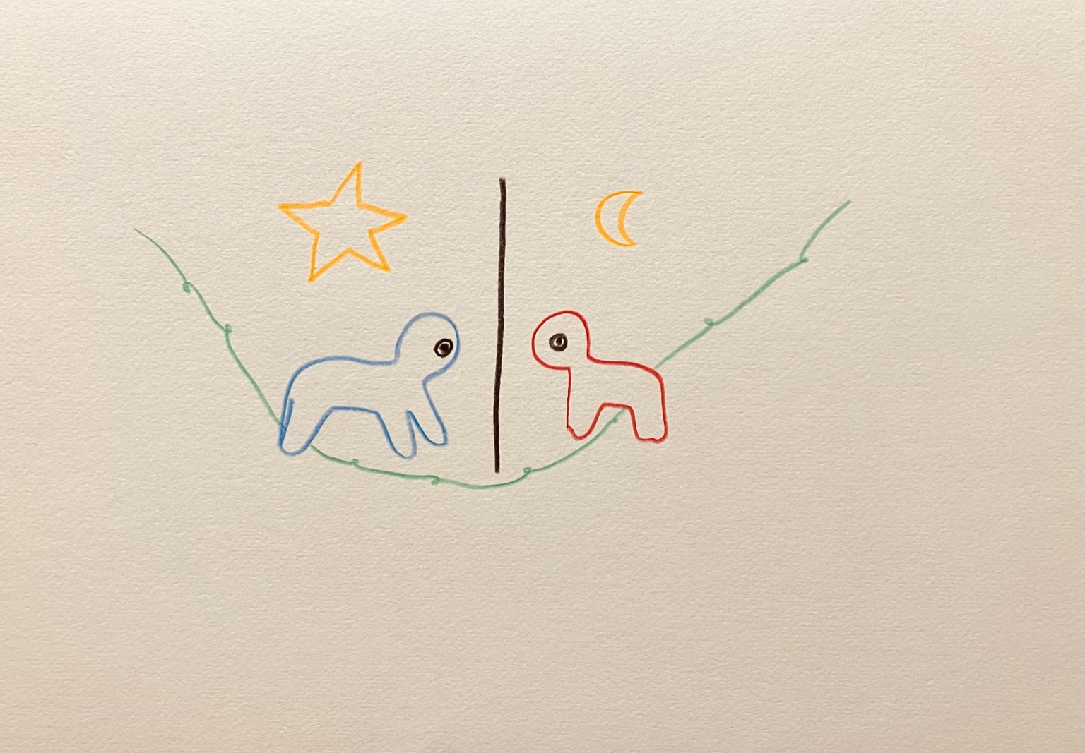resonanz_25-011

To the overview Resonanzräume der Usien

