To the overview “Resonanzräume der Usien“
<< previous | next >>
Array
deutsch

Room 6 - The Boy Who Knew When the Light Would Come
He gets up in the morning, long before the light comes. He doesn’t need to see that it’s daytime – he knows. His little brother is still asleep, the heater makes that soft cracking sound their mother calls “wall-breathing.” Outside, a car drives by, and somewhere a fridge hums like a cautious dog.
He tiptoes to the windowsill to count the little plants. They’re growing. Slowly. But they are growing. He has given them names. Not like pets. More like promises. At school they say he should stop making things up. But he knows: Some things exist before they are spoken.
His father isn’t back yet. Or maybe never was. That doesn’t matter anymore. He’s learned something else: when the air changes. when someone thinks he’s small, even though he’s not. when it’s better to hold your voice like a bird, instead of letting it flutter.
Today, he’s decided, he will stay quiet. But only on the outside. Inside, he’ll count how often someone looks at him without noticing. And then – for himself – he will draw the right stars. Not from the sky. But from the space in between.
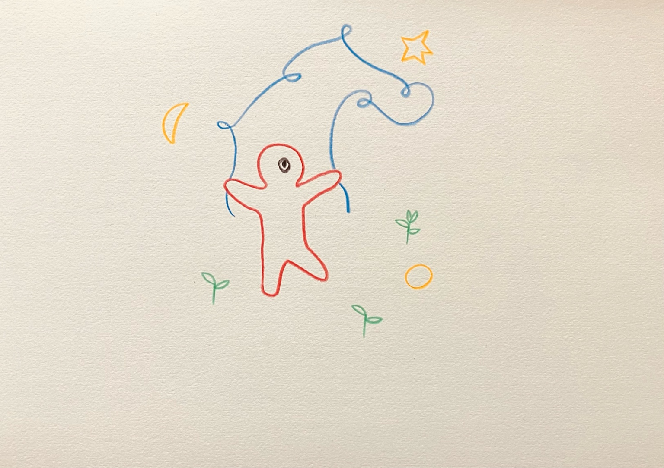resonanz_25-006

To the overview Resonanzräume der Usien

