Zu den Resonanzräumen der Usien
Array
deutsch

Room 3 - In a world that has already been decided
It's a boy, let's call him Eli. He lives in a small town somewhere between Nebraska and Iowa, in what is often referred to as „heartland“, even if the hearts there sometimes beat very quietly. Eli is seventeen, drives a pickup truck that rusts more than it rolls, and has an old mobile phone with a cracked screen that runs TikTok when the diner's wifi is sufficient.
Eli is angry, but he doesn't know exactly what he's angry about. He often says that everything is „not real“, referring to politics, school, future plans. His family almost lost the farm, not to a storm, but to a bank. His father no longer talks much. His mother works three jobs. Eli has no siblings, but a dog that is old and limps. He says that he thinks the world is already decided before he has even been able to contribute anything. He has the feeling that he has been placed somewhere like in a play whose plot has already been written.
And when we spoke, I had the impression that his anger was a mask that actually concealed a huge need: to be needed. That his questions were never really asked, but that he was only ever defending himself against a silence that was bigger than he was.

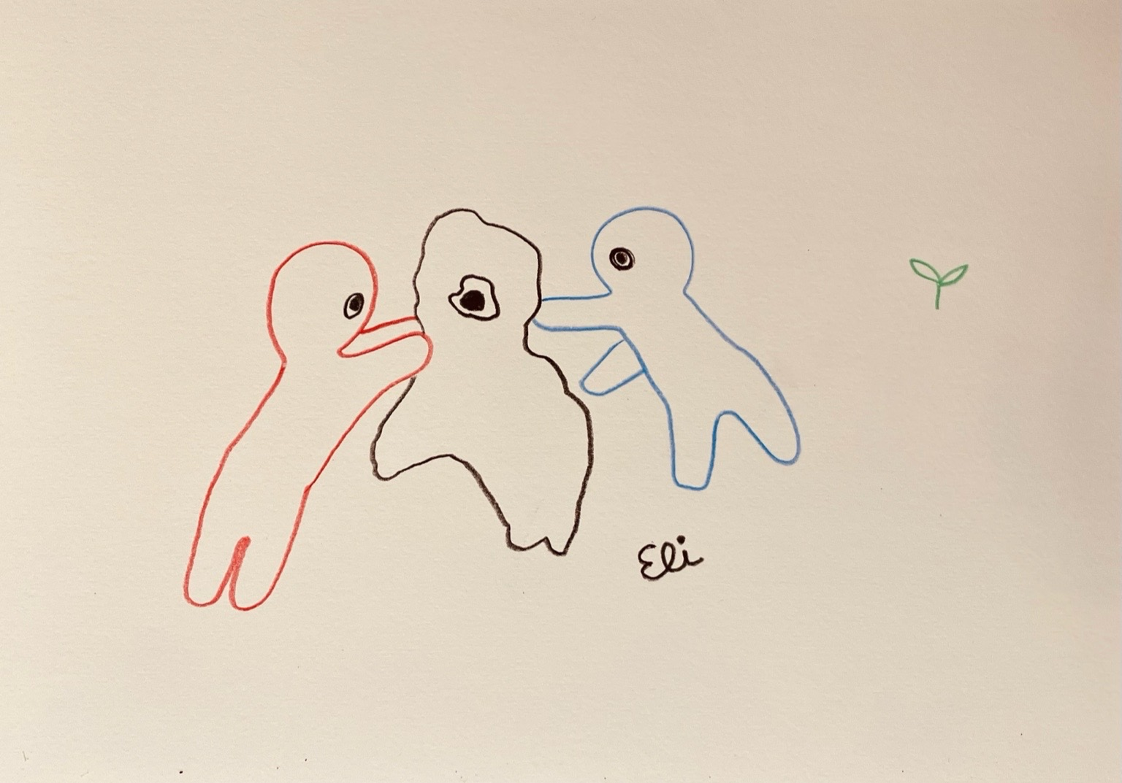resonanz_25-003.jpg

Zu den Resonanzräumen der Usien

