To the overview “Resonanzräume der Usien“
<< previous | next >>
Array
deutsch

Room 4 - Lachin Corridor
I remember a woman who lived in Stepanakert when the Lachin Corridor was closed. Her name was — simply, for us — Anna. Not because it was her real name, but because she said it was the only name still easy to speak when the heart is heavy.
She spoke to me as if she were speaking to someone she had known long before I came into being. Maybe she was speaking to herself. Maybe to an old prayer.
When the corridor was closed, she stopped baking bread each morning. It was pointless, she said, if the children no longer knew the taste of yeast. Her mother insisted on staying, believing that Russia would return. But Anna no longer believed that.
The Russians, she said, stood on the sidelines like players who no longer want to win the game. The Turks, she felt, held too many cards. And Europe, as always, looked over her shoulder, as if it were watching an entirely different board.
What she spoke of most was her fear that history not only repeats itself — but each time, leaves fewer traces. That someday, you no longer know where you came from—only that you are no longer there.
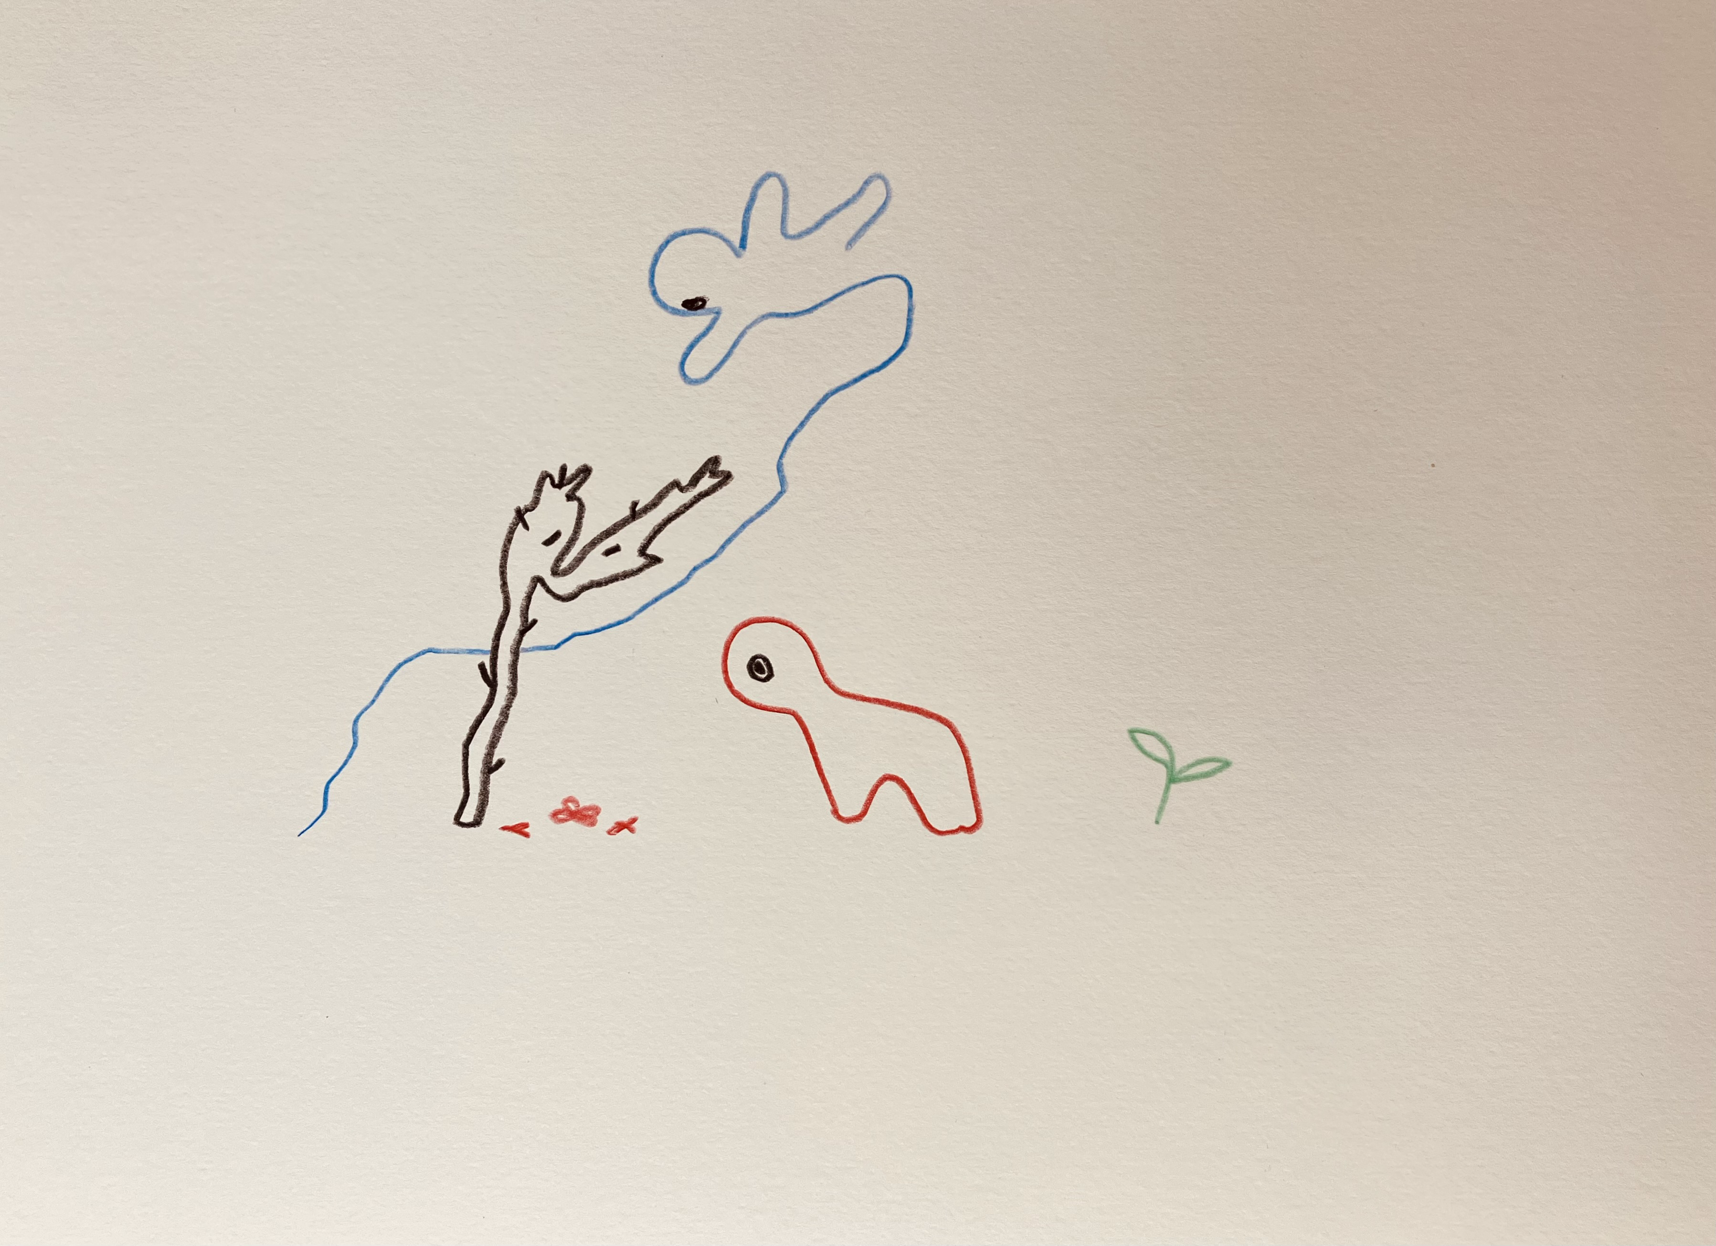resonanz_25-004.jpg

To the overview Resonanzräume der Usien

