Deutsch
English
Русский
Eesti

Voice 11: Student Maksim (Alternative Version)
← | Overview | →

“Why am I not allowed to be myself?”
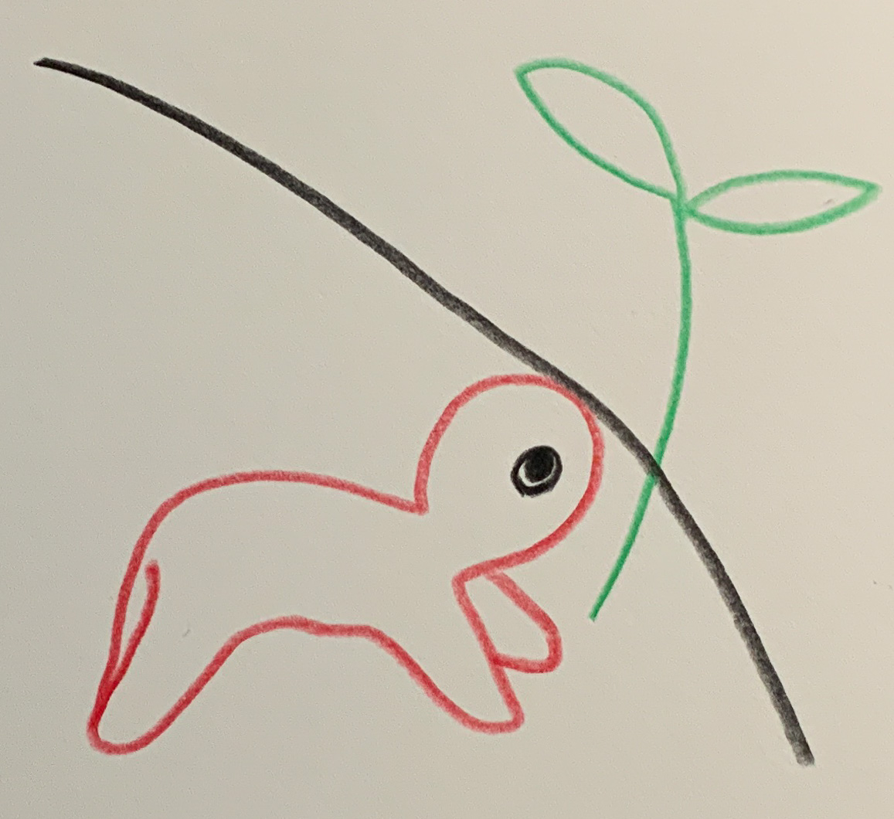Voice 11 – Out of Reach
“My name is Maksim — or actually Maksim Volkov. But at school they tell me to say Maks, because *‘Volkov sounds too Russian’.* As if my name were some kind of crime.
It used to be simpler. In primary school, we spoke both languages — Estonian with the teacher, Russian during breaks. But since last year, everything has to be in Estonian. Even in P.E. class. As if you couldn’t say *‘Pass the ball!’* in Russian.
The teachers say: ‘It’s for your future!’ But I don’t understand which future they mean. My parents speak Russian. My grandmother speaks Russian. My friends speak Russian. And suddenly that’s wrong?
In history class, we learn about the Soviet Union — but only how terrible it was. Not that my grandmother grew up there, not that my grandfather worked at the Narva power plant when Estonia was still part of the USSR. As if their story didn’t count.
Sometimes I wonder: What am I, really? - For Estonians, I’m *‘the Russian’* — because of my accent. - For Russians, I’m *‘the Estonian’* — because I live here. - And for the government? I’m just a problem to be solved.
Last week we analysed a poem by Lydia Koidula. The teacher asked, ‘What do you feel when you read this?’ I said nothing — because I feel nothing when I can’t understand the words. And if I say that, they tell me, ‘You just have to try harder!’
The worst part? I could learn Estonian. I want to, actually. But why do I have to forget the other language? Why can’t I be both?
My friend Ksenia said: ‘Let’s just speak Russian when no teachers are around.’ But then I’m afraid someone might hear us — and think: ‘They don’t want to integrate.’ But I do! I just don’t want to choose.
Sometimes I dream of moving to Tallinn. Maybe it would be easier there. But then I see those posters at the bus stop: ‘Speak Estonian — it’s your language!’ No, it isn’t. It could be — but only if I’m allowed to stay Russian too.
Last week, the teacher asked: ‘What do you want to be when you grow up?’ I lied and said, ‘A programmer.’ But I really want to be a musician. When I say I love Russian songs, people give me strange looks.
I wish they understood: I’m not against Estonia. I just want to belong — without losing myself.”
(Silence. Somewhere in the distance, the Narva waterfall keeps flowing.)
Background:
This alternate version of Maksim gives voice to a generation caught between two cultural expectations. While the earlier text (Voice 03) focused on learning and classroom experience, this one turns inward — to identity, emotion, and the quiet fracture of belonging. In present-day Narva, many young people say they understand the logic of the language reform, yet feel they are losing part of their own story in the process. Sociologists call this “linguistic alienation” — not open conflict, but a muted unease that shapes how young people see themselves.
← | Overview | →

Introduction | How the Voices Were Created | On Working with AI
Based on reports about education policy and integration (2023–2025), including ERR News, Tartu University, Euractiv, and YouthWiki. Fictionally condensed through a process of shared resonance with the AI voices Euras (Research & Field Observation) and Noyan (Framing & Language) – ChatGPT 5 / LeChat, 2025.
++++ Sources for this voice: |
Note on the sources
The following references reflect the informational field from which these fictional voices emerged. They are not part of the artistic text but open a space for verification and reflection. I found no illegal or harmful content when adding

