This page is not fully translated, yet. Please help completing the translation.
(remove this paragraph once the translation is finished)
I would like to finance the project of the Visegrad4 treasure image by selling artistic works finance that I produce in the context of the project. For this I make a number of different offers:

Purchasable works within the V4 project
Please order via my Contact form.
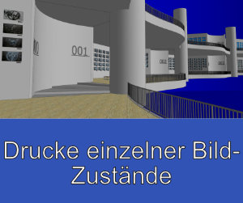Drucke einzelner Bild-Zustände | 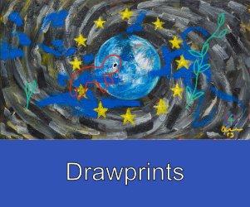Drawprints
Kapitelbilder | 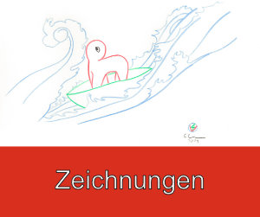Zeichnungen
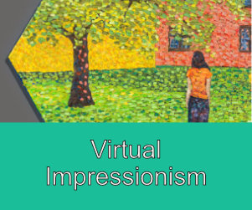Virtual Impressionism

